Armenian Genocide
The Armenian Genocide took place during World War I between the years 1915- 1918 against the Armenian people in the Ottoman Empire (now Turkey). The Young Turk political faction of the Ottoman Empire sought the creation of a new Turkish state extending into Central Asia. Those promoting the ideology called "Pan Turkism" (creating a homogenous Turkish state) now saw its Armenian minority population as an obstacle to the realization of that goal. Thus, extermination of the Armenian people began.
The Armenian people suffered abduction, torture, massacre, starvation and were methodically massacred throughout the Ottoman Empire. The great bulk of the Armenian population was forcibly removed from Armenia and Anatolia to Syria, where the vast majority was sent into the desert to die of thirst and hunger It is estimated that 1.5 million Armenians perished between 1915 and 1923, half of the approximately three million Armenian population that had dwelled in Armenia for 3000 years.
Survivors of this genocide were forced into exile and have never been able to return. An entire people and their history, were virtually erased within years. Although the Young Turk government took precautions and imposed restrictions on reporting and photographing, there were many foreigners in the Ottoman Empire who witnessed these atrocities. Among them were U.S. diplomatic representatives and American missionaries. They were the first to send news to the outside world about the unfolding genocide. Some of their reports made headline news in the American and Western media. Also reporting on the atrocities committed against the Armenians were many German eyewitnesses. The international community condemned the Armenian Genocide. In May 1915, Great Britain, France, and Russia advised the Young Turk leaders that they would be held personally responsible for this crime against humanity. There was a strong public outcry in the United States against the mistreatment of the Armenians. To this day, the Turkish government denies that genocide against the Armenians was carried out.

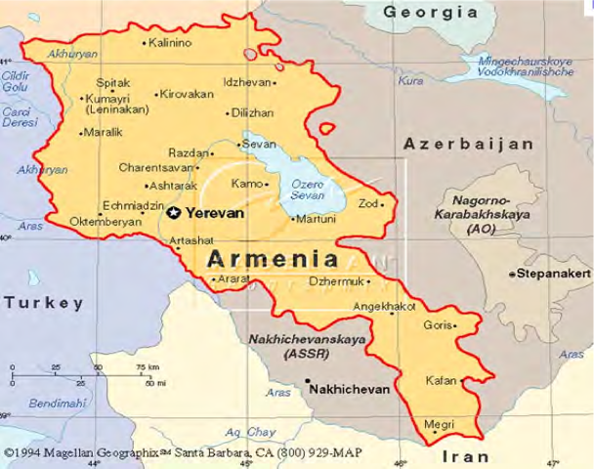

The Ukrainian Genocide Famine Holodomor

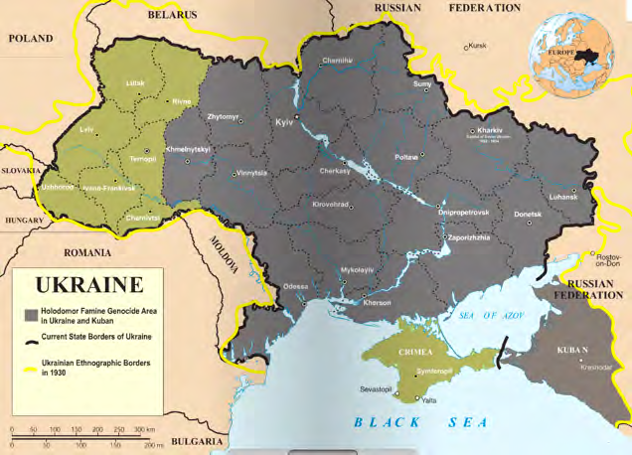

Holodomor, the Ukrainian famine/genocide of 1932-1933 was not caused by a bad harvest, natural disaster or the consequence of war. Ukraine was the last place one would have expected famine, for it had been known for centuries as the "breadbasket of Europe.” The Holodomor (translated "murder by hunger") !was a man-made famine created by the Soviet dictator Josef Stalin.
When Lenin died in 1924, Joseph Stalin succeeded him. To Stalin, the strong national consciousness of the Ukrainian people and the continuing loss of Soviet influence in Ukraine, were completely unacceptable. To crush the peoples’ free spirit, he resorted to the same methods he had used within the Soviet Union. Beginning in 1929, over 5,000 Ukrainian scholars, scientists, cultural and religious leaders were arrested after being falsely accused of plotting an armed revolt. Those arrested were either shot without a trial or deported to prison camps in remote areas of Russia.
Stalin also imposed the Soviet system of land management by the state known as

collectivization. All privately owned farmlands and livestock were seized in a country where 80 percent of the people were farmers. Stalin believed that the peasant landowners known as “kulaks” would be instrumental in any national aspiration. He believed any future revolts would be led by the “kulaks”. Thus he proclaimed that it was necessary to liquidate the “kulaks” as a class and declared the “kulaks” "enemies of the people." The borders of Ukraine were closed, which prevented any food from coming into the country. Soviet police inside Ukraine went from house to house seizing any stored up food, leaving farm families without a morsel. All food was considered to be the "sacred" property of the State. Anyone caught stealing State property, even an ear of corn or stubble of wheat, could be imprisoned for not less than ten years or shot. In 1932-1933, while the Soviet government sold massive quantities of Ukrainian grain to foreign markets, starvation quickly ensued throughout Ukraine. In 1932-1933, an estimated 10 million people perished from starvation.
The Cambodian Genocide

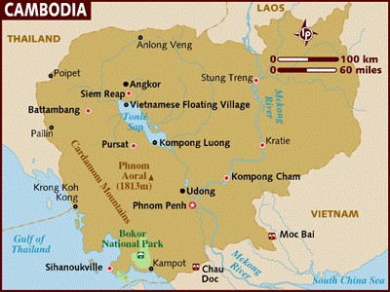

By 1975, the U.S. had withdrawn its troops from Vietnam. Cambodia also lost its American military support which resulted in their government becoming corrupt and incompetent. Taking advantage of this opportunity, Pol Pot's Khmer Rouge army, consisting of teenage peasant guerrillas, marched into Phnom Penh and, on April 17, effectively seized control of Cambodia.
Once in power, Pol Pot began a radical experiment to create an agrarian utopia in Cambodia, which he renamed the Democratic Republic of Kampuchea. Khmer Rouge’s polices were guided by its belief that the citizens of Cambodia had been tainted and corrupted by exposure to outside ideas, especially those from the capitalist West.
He began by declaring, "This is Year Zero," and that society was about to be "purified." Capitalism, Western culture, city life, religion, and all foreign influences were to be extinguished in favor of an extreme form of peasant Communism.
The Khmer Rouge persecuted those who were educated, such as doctors and lawyers, and those who were or had been in the military or police force. Its goal was to create a society in which no one competed against another and all people worked for the common good. This was accomplished by placing people in collective living arrangements, or communes. All foreigners were thus expelled, embassies closed, and any foreign economic or medical assistance was refused. The use of foreign languages was banned. Newspapers and television stations were shut down, radios and bicycles confiscated, and mail and telephone usage curtailed. Money was forbidden. All businesses were shuttered, religion banned, education halted, health care eliminated, and parental authority revoked. Thus, Cambodia was sealed off from the outside world.
All of Cambodia's cities were then forcibly evacuated. At Phnom Penh, two million inhabitants were evacuated on foot into the countryside at gunpoint, and as many as 20,000, died along the way. Millions of Cambodians, accustomed to city life were now forced into slave labor in Pol Pot's "killing fields" where they soon began to die from overwork, malnutrition and disease, on a diet consisting of one tin of rice (180 grams) per person every two days. Workdays in the fields began around 4 a.m. and lasted until 10 p.m., with only two rest periods allowed during the 18 hour day, all under the armed supervision of young Khmer Rouge soldiers eager to kill anyone for the slightest infraction. Starving people were forbidden to eat the fruits and rice they were harvesting. After the rice crop was harvested, Khmer Rouge trucks would arrive and confiscate the entire crop. Throughout Cambodia, deadly purges were conducted to eliminate remnants of the "old society" - the educated, the wealthy, Buddhist monks, police, doctors, lawyers, teachers and former government officials. Ex-soldiers were killed along with their wives and children. Anyone suspected of disloyalty to Pol Pot, eventually including many Khmer Rouge leaders, was shot or bludgeoned with an ax. "What is rotten must be removed," a Khmer Rouge slogan proclaimed.

The Bosnian Genocide

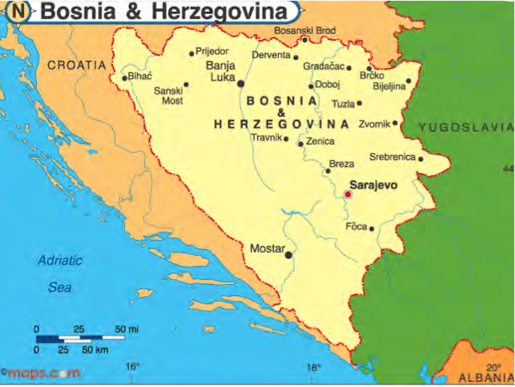

Bosnia (Herzegovina) is one of several small countries that emerged from the break-up of Yugoslavia. Yugoslavia was composed of ethnic and religious groups that had been historical rivals, and included the Serbs (Orthodox Christians), Croats (Catholics) and ethnic Bosniaks and Albanians (Muslims).
Nazi Germany invaded and partitioned Yugoslavia during World War II. After Germany’s defeat, Josef Broz Tito, led a fierce resistance movement and reunified Yugoslavia under the slogan "Brotherhood and Unity," merging together Slovenia, Croatia, Bosnia, Serbia, Montenegro, Macedonia, along with two self-governing provinces, Kosovo and Vojvodina. After Tito’s death in 1980, and without his strong leadership, Yugoslavia quickly tumbled into political and economic chaos. In the 1980’s Slobodan Milosevic, a Serbian, gained power through religious hatred and nationalism and provoked tensions between Serbs and Muslims by encouraging Serb nationalism in the republics where there were large Serb communities. Over the years, the bitterness and hostility of the rival ethnic and religious groups sharing the same country was brewing and bubbling, until a civil war finally erupted in the early 1990s. In 1991 Croatia, Slovenia and Macedonia declared independence. Bosnia parted from Yugoslavia and became an independent nation in 1992. The largest population of Bosnia was made up of Muslims, while Serbs became the minority, accounting for about 32% of the Bosnian population. Once Bosnia was declared an independent nation, many of the Serbs residing in Bosnia were bitter and decided to take action. Between April 1992 and November 1995, Serbia set out to “ethnically cleanse” Bosnian territory by systematically removing all Bosnian Muslims. It is documented that approximately 200,000 lives were taken during the occurrence of the Bosnian genocide. In the course of the war as many as 1 million Muslims in Bosnia were forced to flee their homes.
The procedure of the Bosnian genocide was comparable to the Holocaust. Men were systematically lined up and grouped to be gunned down and brutally murdered. Boys over the age of 13 were also main targets of the Serbs during the Bosnian genocide. Many Bosnian Muslims were driven into concentration camps, where women and young children were victims of sexual violence and rape, and many were starved. The Bosnian genocide is a truly horrific event that left thousands of families separated. Even today, there are people considered missing and thousands more without a proper burial and funeral.

The Rwandan Genocide

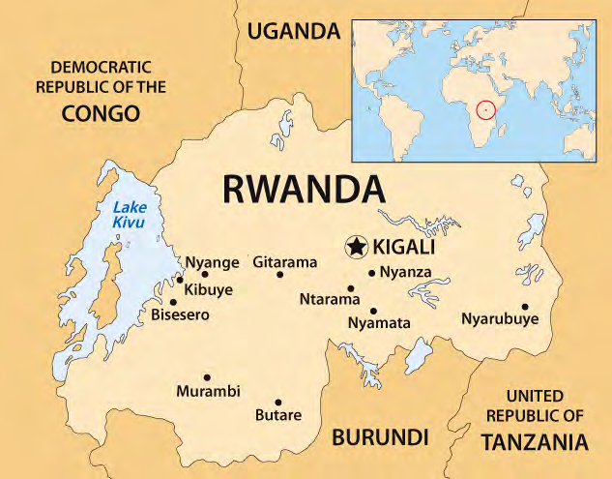

Most of the Rwandan population belonged to the Hutu ethnic group, traditionally crop-growers. For many centuries Rwanda attracted Tutsis - traditionally herdsmen - from northern Africa. For 600 years the two groups shared the business of farming, essential for survival. They also shared their language, their culture, and their nationality. There had been much intermarriage. Tutsis tended to be landowners and Hutus, worked the land, with the Hutus outnumbering the Tutsis. When the European colonists came, they selected the Tutsis as the privileged group, and thus introduced class awareness, as well as modern weapons.
The Hutus acquired power and were taking away Tutsi rights. Tutsi were excluded from secondary schools and universities. Many Tutsis retreated into neighboring countries where they trained their soldiers. Tensions, resistance and internal conflicts grew. In 1990 civil war began. 1993 brought a cease-fire and the UN negotiated a multi- party constitution. The Hutu leaders and extremists, however, opposed Tutsi involvement in government.
On April 6 1994 the plane carrying Rwanda's president was shot down, most probably the work of an extremist. This was the trigger needed for the Hutus' planned 'Final Solution' to go into operation. The Tutsis were accused of killing the president, and Hutu civilians were told, by radio and word of mouth, that it was their duty to destroy the Tutsis out. Hutus who were sympathetic to the Tutsi were killed also. These events began the Rwandan Genocide, which was a systematic killing against the Tutsi minority and the opposition to the Hutu majority.
Local officials rounded up victims and began slaughtering victims. Tutsi men, women and children were killed in schools and churches by people they knew - neighbors, friends, work partners, even relatives.
It is estimated that from April 6 to the middle of July, Hutu militia groups killed 800,000 to 1 million Rwandans.
The Rwandan Genocide is widely considered a failure for the United Nations and the complaisance of many western nations including the United States, France, and Belgium has drawn heavy criticism. While the United Nations had a special envoy to Rwanda, led by Romeo Dallaire, the UN Security Council failed to respond to the tragedy, and even reduced the size of Dallaire's force, for the first months of the genocide. Other nations, including the United States were reluctant to become involved in what was initially interpreted as a "local conflict."
Genocide in Darfur
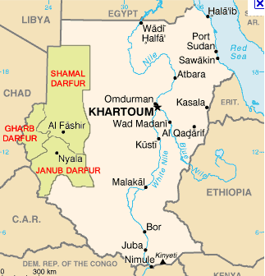

Since its independence from Great Britain in 1956, Sudan, Africa's largest country, has experienced civil war almost continuously (except from 1971-1982).
Darfur, located in western Sudan has become a critical site in Sudan’s civil war. Darfur is divided by religion, ethnicity, tribal differences, and economic disparities. The population of Darfur is comprised of many tribes of settled peasants who identify as African and nomadic herders who identify as Arab. The majority of both are Muslim.
Throughout much of Darfur’s history, considerable tension has existed amongst its various Arab and non-Arab populations. Recent competition over access to land and water has aggravated the strife between Arabs, who are primarily nomadic herdsmen, and non-Arab farmers. In February 2003, the non-Arab ethnic groups of Darfur launched an uprising against the Khartoum government. They struck out against the government, accusing it of oppressing non-Arabs, and favoring Arabs. The government responded by implementing their campaign of genocide, enlisting the help of Arab militia in Darfur called the Janjaweed. The Janjaweed are the armed militia supported by the Sudanese Government to carry out the genocide. The dispute is racial, not religious: Muslim Arab Sudanese are killing Muslim black Sudanese. In the ongoing genocide, African farmers and others in Darfur are being systematically displaced and murdered at the hands of the Janjaweed.
The genocide in Darfur has claimed 400,000 lives as a result of attacks and induced malnutrition and disease. The majority of these had been women, children and civilian men. More than one hundred people continue to die each day; five thousand die every month. This genocide has displaced over 2, 500,000 people.
The Janjaweed will enter a village on horse back or camel. They then cause as much mayhem and terror as possible: destroying houses and buildings, shooting the men, gang raping the women and children and shooting any who try to escape. The village is generally destroyed, families dispersed and separated, most killed. Those who manage to escape then attempt the long journey to an IDP (internally displaced persons) camp. The violence is now spilling onto neighboring Eastern Chad. The Sudanese government has resisted U.N. appeals for intervention. Instead, it continues to support the Janjaweed’s systematic assaults against non-Arab Darfurians.

